Request:

Auto print of pick slip by SO Line after uploaded of SO file.

**From:** Marcus, Tong   
**Sent:** Monday, 14 March, 2016 11:52 AM  
**To:** Chan, Pei-Fong; Marcus, Tong  
**Subject:** RE: SKH Stocking Order & SPLIT Request 20160311 (10 AM) - ZSCBUILD ( Report auto print by S/o line )

Hi Pei Fong,

As spoken will like to request during uploading S/o file and to have S/o line auto printed by the attached format highlighted in green.

Below are the ideal picklist look like, we advise can it be done.

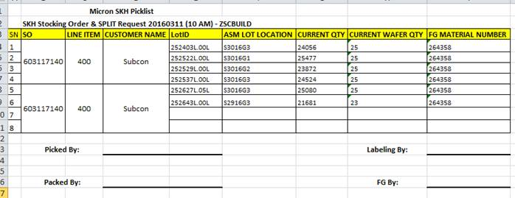

Request for the Pick Slip Format and layout:

1. 1 SO+Poline = 1 pick slip
2. Sorting to be followed the uploaded file sequence.
3. Sub-group every 4 lines is optional. System can fix the grouping at every 4 detail lines.
4. Report title to get from the uploaded file name. i.e.

“SKH Stocking Order & SPLIT Request “ + {filename}